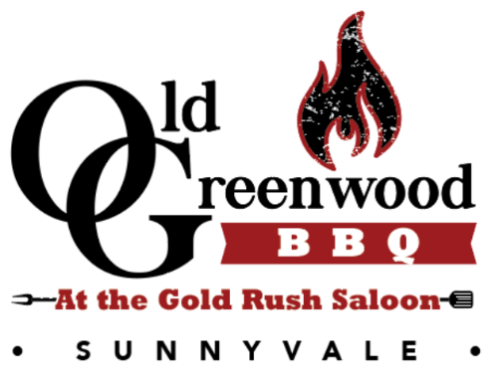
FoodTruck Menu
Harris Ranch Burgers
All Burgers Are Made with a Fresh 1/2 lb Harris Ranch Beef Patty
OG CLASSIC- $9.99
American Cheese, Lettuce, Tomato, Pickled Red Onion
FRONTIER- $10.99
American Cheese, Applewood Chopped Bacon , Onion Ring, Sweet & Spicy BBQ Sauce
ATOMIC -$10.99
Jalapeno, Pickled Onion, Chipotle Ranch
VEGGIE- $9.99
Garden Veggie Patty, Lettuce, Tomato
Slow Smoked Pulled Pork Sandwich -$10.99
1/3 Slow-Smoked Pulled Pork, Coleslaw, Pickled Red Onion
Shareables
CHICKEN WINGS -$12.99
10 Crispy Wings, Choice of Buffalo, Lexington Pig Splash, Carolina Mustard, or Sweet and Spicy Sauce
LOADED TOTS- $8.99
Tater Tots, Nacho Cheese, Applewood Chopped Bacon, Ranch, Green Onion

SIDES
Bermuda Onion Rings $5.00 Tater Tots $4.25 Natural Cut Fries $4.25
Beverages
Devils Canyon Craft Root Beer 16 oz $4.25 Devils Canyon Craft Root Beer Float $5.00
Can Soda $1.50 Bottled Water $1.50

FOODTRUCK
CATERING INFO/MENU
Do you have a private party or a corporate event and need catering? Consider hiring us instead! Food truck food service is a unique and fun way to add a twist to your event. Contact Lisa (408) 743-5336 or email us at oldgreenwoodbbqevents@gmail.com for more information!
Fundraising Opportunity: Hire us for your fundraiser and we will donate 10% of our proceeds (exceeding $1,000) to your cause!
Slow Smoked BBQ Food Truck Catering Packages
Per Person Foodtruck Catering Packages: Include 1 corn Muffin Per Person and choice of all three BBQ Sauces
1 Meat PLUS 2 Sides ………………………………… $17/Person
2 Meats PLUS 2 Sides……………………………….. $20/Person
3 Meats PLUS 2 Sides……………………………….. $23.50/Person
The same two sides will be served for your whole party!
Meats Choices:
Slow Smoked Pork, OG Tri Tip, Pit Smoked Chicken Boneless Thighs
¼ BBQ Chicken (Bone in Drumstick and Thigh), St Louis Style Ribs
Louisiana Hot Link
Side Choices:
Slaw, Beans, Potato Salad, Collard Greens with Bacon, Corn Salad, Green Salad (w/choice of Ranch, Balsamic or Blue Cheese dressing), Caesar Salad
BBQ Sauce Choices:
Carolina Gold, Lexington Pig Splash, and Sweet and Spicy

FOODTRUCK
BURGER/BBQ Sandwich Packages
A. Regular burger or sandwich, Tots or Fries $14.50 pp (one side option for party
B. Regular burger or sandwich, Tots or fries, Rootbeer or RB Float $16. pp (one side option for party)
C. Premium burger or sandwich (or regular burger) or sandwich, Tots, fries or rings $17.50 pp (one side option for party)
D. Premium burger or sandwich ( or regular burger) or sandwich, Tots, Fries or rings, Rootbeer or RB Float $19.50 pp (choice of side option for party)
WE ADD 9% CA SALES TAX TO YOUR FINAL EVENT CHARGE
WE ADD 15% GRATUITY TO YOUR FINAL EVENT CHARGE
PLEASE CHOOSE 4-5 BURGERS/SANDWICHES FROM OUR FOODTRUCK MENU TO HAVE AS OPTIONS FOR YOUR EVENT!
ALLOW 1 HR FOR EVERY 100 GUESTS SERVICE TIME. Extra Hours to book the truck as a ”centerpiece” available at an hourly charge
MINIMUM CATERING CHARGE OF $950
PLEASE USE THE “CONTACT US” FORM ON THIS WEBSITE TO GET AN ESTIMATE FOR YOUR EVENT. Please SPECIFY THE 1. DATE 2. TIME 3. LOCATION 4. NUMBER OF GUESTS. 5. PACKAGE SELECTION

